Date: Monday June 1st 2020 ASSIGNMENT #9 Due on June 8th

1. PERFORMANCE: NO NEW RECORDER SCALE & SONG:
Use this week to catch up on videos

*RECORD THE VIDEO on your cell phone or computer : (one single video in this order)
1. Record the Bb scale tonguing every note from the scale sheet page
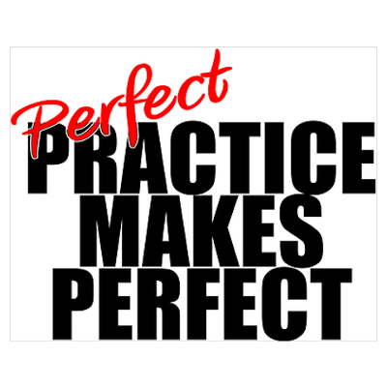
2. Be careful with the fingering for Bb and Eb. (Use fingering page)
3. Record “Scarborough Fair.” You can get help with rhythm from youtube
4. Make sure that you and your hands are visible!
5. Share your video through Google Drive with robert.kettle@tdsb.on.ca
* I hope that everybody has been able to find a wind instrument. I know that one student was able to get a recorder from a music store for $7.49 + tax. If you order ahead of time, the store will bring the item to you outside the store. Percussionists could use a keyboard/piano/ toy xylophone, but it might be more fun to try the recorder or make yourself a glass harmonica!

A few of you have your school instrument. You could play the tune as is. (If you are a transposing instrument such as clarinet or trumpet you will sound in a key one tone lower than what is written.) There is also a bass version for anybody reading bass clef.
It is important to practice everyday! Sometimes finding practice space is difficult. Be creative.
Ask your parents about possible practice space in your building.

2. THEORY: Please try worksheet 1i) Time Signatures

earlhaig.ca> Departments> Music> Music Downloads> Mr Kettle>

1) BAND> 2) AMI1O1> 09) ON-LINE INSTRUCTION> 09) June 1st

